Coding challeng exam in sql 15

create database college;
use college;

create table students (
student_id INT PRIMARY KEY,
student_name VARCHAR(50),
gender VARCHAR(10),
city VARCHAR(50),
join_year INT
);

INSERT INTO students (student_id, student_name, gender, city, join_year) VALUES
(1, 'Anu', 'F', 'Tumakuru', 2024),
(2, 'Ravi', 'M', 'Bengaluru', 2023),
(3, 'Kiran', 'M', 'Tumakuru', 2024),
(4, 'Sneha', 'F', 'Mysuru', 2023),
(5, 'Manu', 'M', 'Tumakuru', 2022)

CREATE TABLE courses (
course_id INT PRIMARY KEY,
course_name VARCHAR(100),
department VARCHAR(50)
);

INSERT INTO courses (course_id, course_name, department) VALUES
(101, 'SQL Basics', 'Computer Science'),
(102, 'Excel for Analysts', 'Commerce'),
(103, 'Statistics', 'Mathematics');

CREATE TABLE marks (
mark_id INT PRIMARY KEY,
student_id INT,
course_id INT,
marks INT,
FOREIGN KEY (student_id) REFERENCES students(student_id),
FOREIGN KEY (course_id) REFERENCES courses(course_id)
);

insert into marks (mark_id, student_id, course_id, marks) VALUES
(1, 1, 101, 85),
(2, 2, 101, 72),
(3, 3, 101, 90),
(4, 4, 102, 88),
(5, 5, 103, 67),
(6, 1, 103, 79),
(7, 2, 102, 81);

Database created with students,courses,marks wise tables alo

1. Display all students.
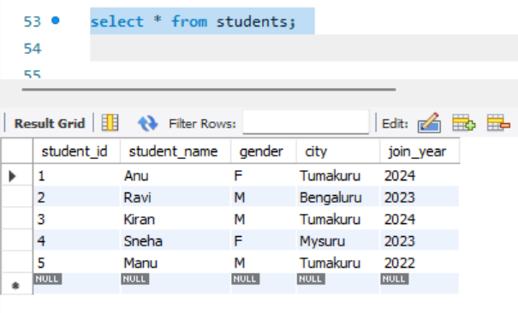

2. Display only student_name and city from students table.

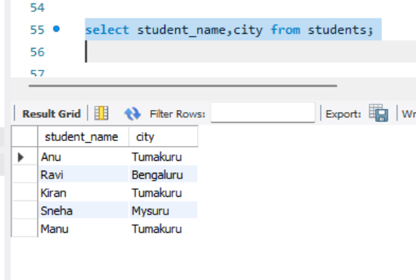

3. Show all courses.

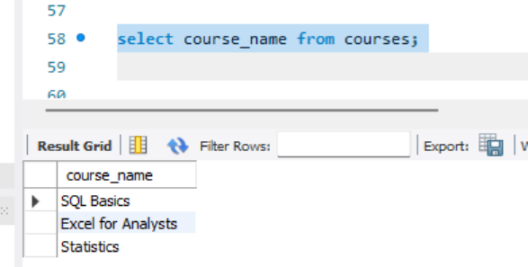

4. Display students who are from Tumakuru.

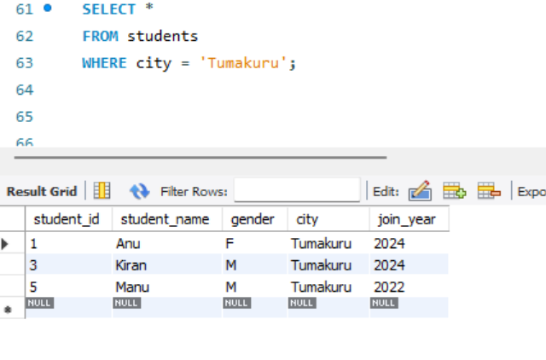

5. Display students who joined in 2024.

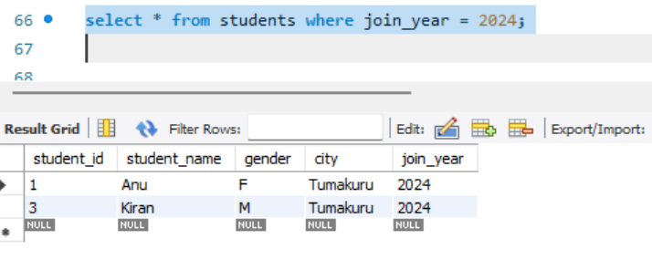

6. Show students whose gender is F.

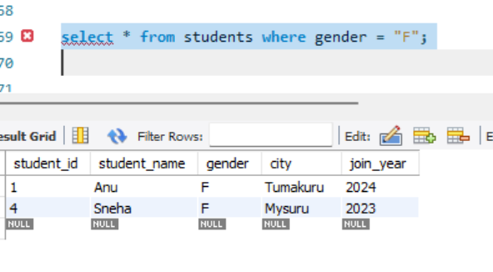

7. Show marks greater than 80.

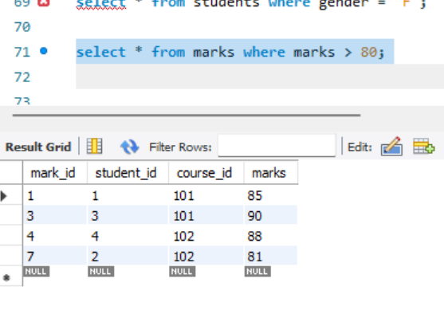

8. Display course names from Commerce department.
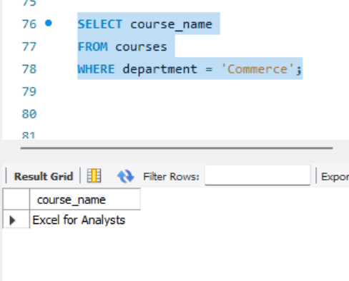

9. Show students who are not from Bengaluru.

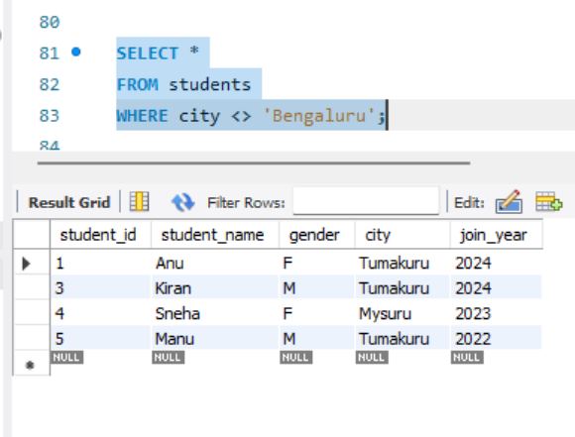

10. Display marks between 70 and 90.

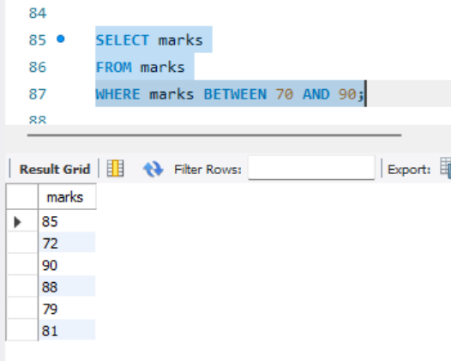

11. Display all students ordered by student_name ascending.

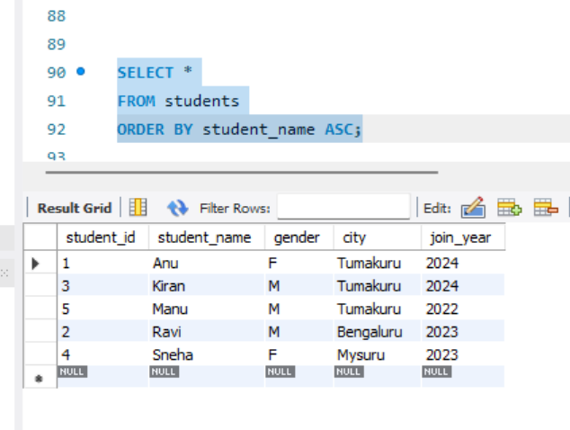

12. Show marks ordered from highest to lowest.

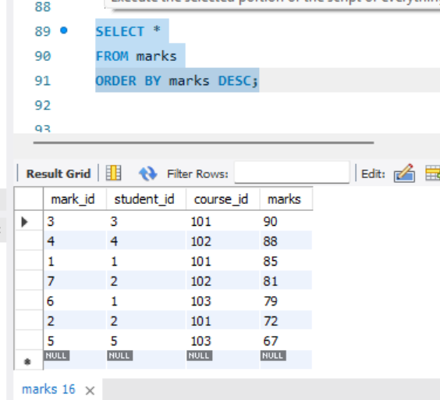

13. Display students ordered by join_year descending.

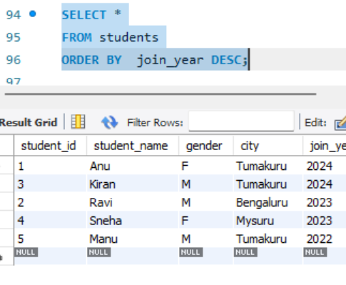

14. Find total number of students.

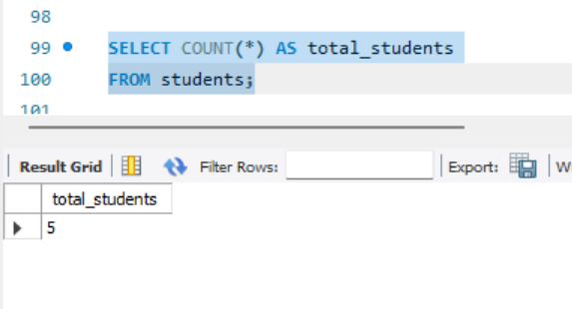

15. Find average marks.
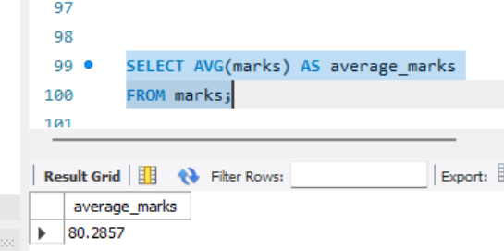

16. Find highest marks.

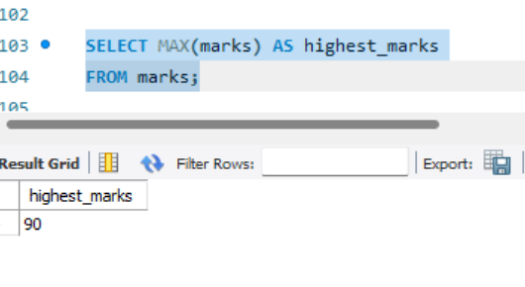

17. Find lowest marks.

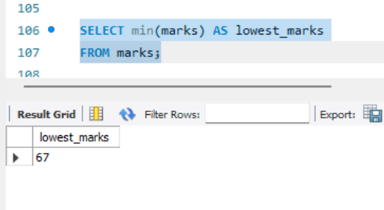

18. Find total marks scored by all students.

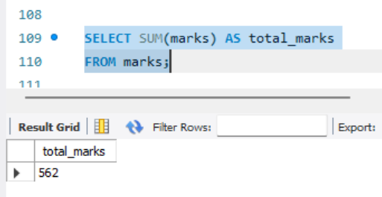

THANK YOU

